ST. XAVIER’S COLLEGE

**(Affiliated to Tribhuvan University)**

**Maitighar, Kathmandu**



**Computer Graphics**

**Lab Assignment #7**

**SUBMITTED BY:**

Sneha Prasai

013BSCCSIT040

**SUBMITTED TO**

|  |  |
| --- | --- |
| Er. Anil Sah  ( Lecturer ) |  |
| Department of Computer Science | |

**STATEMENT:**

**To Implement 2DTranlsation, Scaling And Rotation.**

**Source Code:**

//---------------------------------------------------------------------------

#include <vcl\vcl.h>

#pragma hdrstop

#include <Math.h>

#include "Unit1.h"

//---------------------------------------------------------------------------

#pragma resource "*.dfm"

TForm1 *Form1;

int i,x,y,a,b,j,angle;

//---------------------------------------------------------------------------

__fastcall TForm1::TForm1(TComponent* Owner)

: TForm(Owner)

{

}

//---------------------------------------------------------------------------

void __fastcall TForm1::TranslateClick(TObject *Sender)

{

x=Image1->Height;

y=Image1->Width;

for(i=0;i<=x;i++)

{

for(j=0;j<=y;j++)

{

a=i+StrToInt(Edit1->Text);

b=j+StrToInt(Edit2->Text);

Image2->Canvas->Pixels[a][b]=Image1->Canvas->Pixels[i][j];

}

}

}

//---------------------------------------------------------------------------

void __fastcall TForm1::ScaleClick(TObject *Sender)

{

x=Image1->Height;

y=Image1->Width;

for(i=0;i<=x;i++)

{

for(j=0;j<=y;j++)

{

a=i*StrToInt(Edit3->Text);

b=j*StrToInt(Edit4->Text);

Image2->Canvas->Pixels[a][b]=Image1->Canvas->Pixels[i][j];

}

}

}

//---------------------------------------------------------------------------

void __fastcall TForm1::RotateClick(TObject *Sender)

{

x=Image1->Height;

y=Image1->Width;

angle=StrToInt(Edit5->Text);

for(i=0;i<=x;i++)

{

for(j=0;j<=y;j++)

{

a=100+i*cos(angle)-j*sin(angle);

b=100+i*sin(angle)+j*cos(angle);

Image2->Canvas->Pixels[a][b]=Image1->Canvas->Pixels[i][j];

}

}

}

//--------------------------------------------------------------------

**OUTPUT:**

Translation:

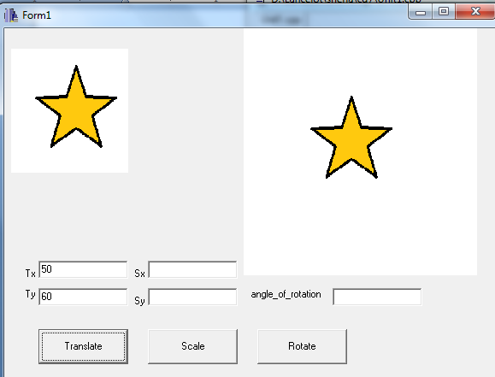

Scaling:

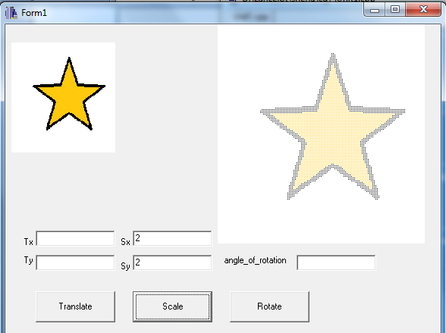

Rotation:

